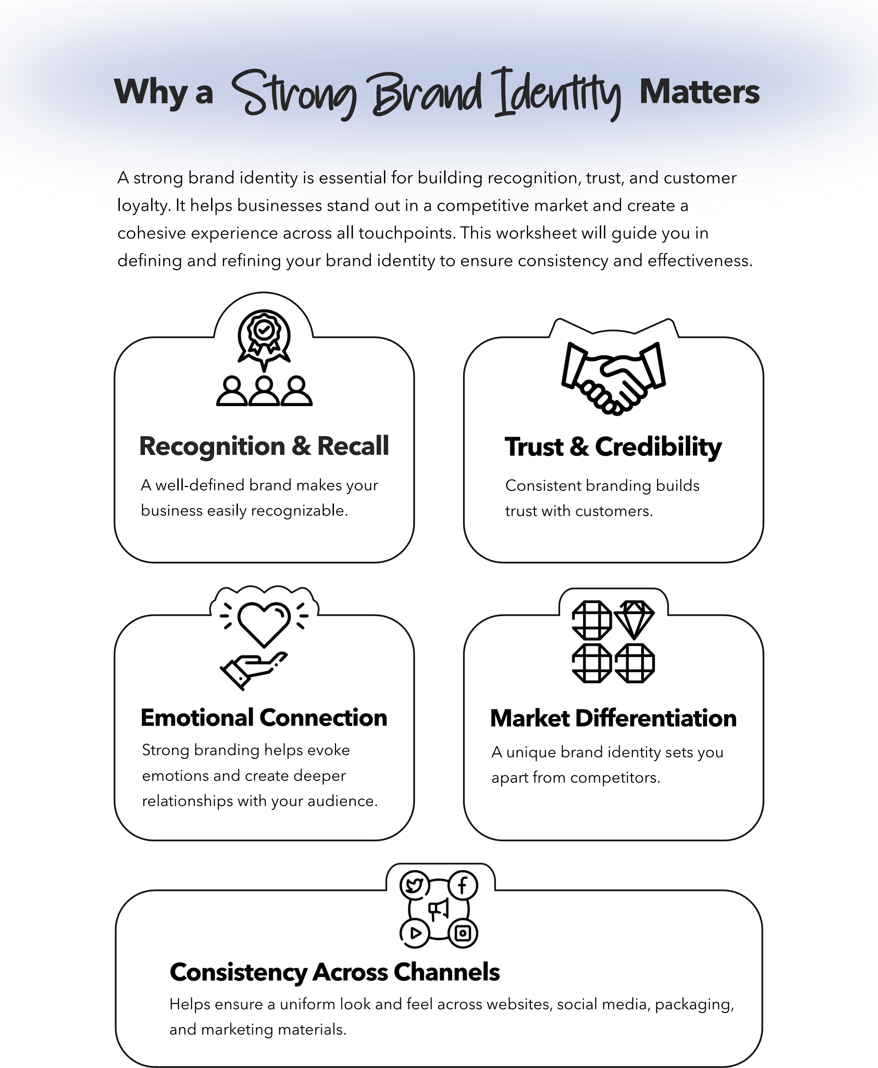


Section 1: Brand Foundations
- Brand Name:
- Tagline/Slogan:
- Mission Statement: (What is the core purpose of your brand?)
- Vision Statement: (What is your long-term goal for the brand?)
- Core Values: (List 3-5 guiding principles of your brand.)
- Brand Personality: (Describe your brand as if it were a person. Example: friendly, professional, innovative, etc.)
- Target Audience: (Who are your ideal customers? Age, location, interests, demographics, etc.)
- Unique Selling Proposition (USP): (What makes your brand different from competitors?)

Section 2: Brand Messaging
- Brand Story: (Briefly describe your brand’s origin and journey.)
- Key Messages: (What are the main points you want to communicate to your audience?)
- Brand Tone & Voice: (Is your brand tone professional, casual, playful, authoritative, etc.?)
- Emotional Connection: (What feelings should your brand evoke in customers?)

Section 3: Visual Identity
- Logo: (Attach or describe your logo concept.)
- Color Palette: (List the primary and secondary brand colors with hex codes if available.)
- Typography: (Specify the fonts used for headings, subheadings, and body text.)
- Imagery & Photography Style: (Describe the type of images that reflect your brand. Example: bright & modern, classic & elegant.)
- Graphic Elements: (Are there specific icons, patterns, or textures associated with your brand?)
- Brand Guidelines: (Do you have a style guide or set of rules for consistent brand application?)

Section 4: Brand Experience
- Website & Digital Presence: (List website URL and social media handles.)
- Customer Experience: (How do you want customers to feel when interacting with your brand?)
- Packaging & Physical Branding: (Describe any product packaging, business cards, signage, etc.)
- Brand Consistency Strategy: (How will you ensure a cohesive brand experience across all touchpoints?)

Section 5: Competitive Analysis & Growth
- Key Competitors: (List top competitors and their strengths/weaknesses.)
- Brand Positioning: (Where does your brand stand in the market compared to competitors?)
- Short-Term Goals (6-12 months):
- Long-Term Goals (2-5 years):
- Next Steps: (What actions are needed to develop or refine your brand further?)

